Sale Price vs Year Build

plot(Sale_Price~Year_Built, data =casedata )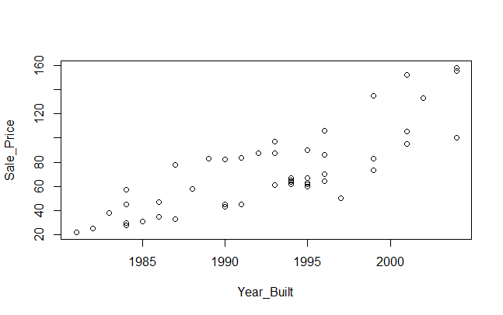

Sale price vs weight

plot(Sale_Price~Weight, data =casedata )

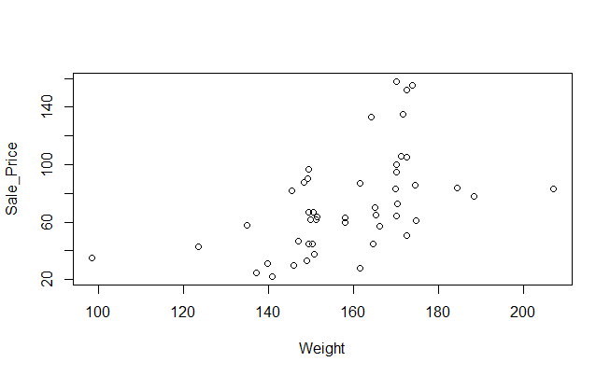

plot(Sale_Price~Capesize, data =casedata )

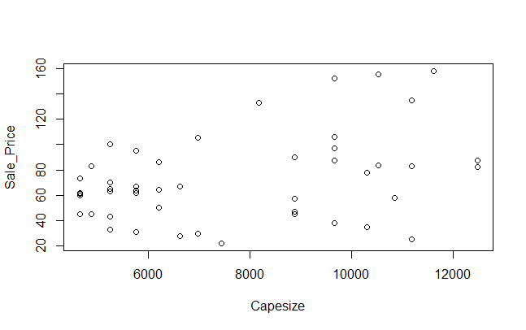

plot(Sale_Price~Sale_Years, data= Ships)

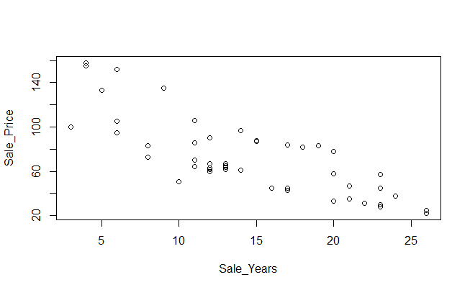

Model Comparison

|  |  |
| --- | --- |
| Weight | > w_model = lm(Sale_Price ~ Weight, data=data, y=TRUE)  > w_model.summary = summary(w_model)  > w_model.summary  Call:  lm(formula = Sale_Price ~ Weight, data = data, y = TRUE)  Residuals:  Min 1Q Median 3Q Max  -47.393 -23.039 -2.777 16.738 74.105  Coefficients:  Estimate Std. Error t value Pr(>|t|)  (Intercept) -84.1651 38.8111 -2.169 0.035321 *  Weight 0.9886 0.2427 4.073 0.000181 ***  ---  Signif. codes: 0 ‘***’ 0.001 ‘**’ 0.01 ‘*’ 0.05 ‘.’ 0.1 ‘ ’ 1  Residual standard error: 29.37 on 46 degrees of freedom  Multiple R-squared: 0.265, Adjusted R-squared: 0.249  F-statistic: 16.59 on 1 and 46 DF, p-value: 0.0001814 |
| Year Build | YB_model=lm(Sale_Price~Year_Built,data = casedata,y=TRUE)  > YB_model.summary=summary(YB_model)  > YB_model.summary  Call:  lm(formula = Sale_Price ~ Year_Built, data = casedata, y = TRUE)  Residuals:  Min 1Q Median 3Q Max  -40.128 -15.411 -5.367 18.643 44.061  Coefficients:  Estimate Std. Error t value Pr(>|t|)  (Intercept) -8551.8747 926.2814 -9.232 4.84e-12 ***  Year_Built 4.3277 0.4648 9.311 3.74e-12 ***  ---  Signif. codes: 0 ‘***’ 0.001 ‘**’ 0.01 ‘*’ 0.05 ‘.’ 0.1 ‘ ’ 1  Residual standard error: 20.17 on 46 degrees of freedom  Multiple R-squared: 0.6534, Adjusted R-squared: 0.6458  F-statistic: 86.7 on 1 and 46 DF, p-value: 3.744e-12 |
| Sales Year | > SY_model = lm(Sale_Price ~ Sale_Years, data=Ships, y=TRUE)  > model.summary = summary(SY_model)  > model.summary  Call:  lm(formula = Sale_Price ~ Sale_Years, data = Ships, y = TRUE)  Residuals:  Min 1Q Median 3Q Max  -40.46 -16.34 -7.15 18.03 44.17  Coefficients:  Estimate Std. Error t value Pr(>|t|)  (Intercept) 133.1295 7.5832 17.556 < 2e-16 ***  Sale_Years -4.2165 0.4866 -8.666 3.15e-11 ***  ---  Signif. codes: 0 ‘***’ 0.001 ‘**’ 0.01 ‘*’ 0.05 ‘.’ 0.1 ‘ ’ 1  Residual standard error: 21.12 on 46 degrees of freedom  Multiple R-squared: 0.6201, Adjusted R-squared: 0.6119  F-statistic: 75.1 on 1 and 46 DF, p-value: 3.147e-11 |
| Capesize | > c_model = lm(Sale_Price ~ Capesize, data=data, y=TRUE) > c_model.summary = summary(c_model) > c_model.summary  Call: lm(formula = Sale_Price ~ Capesize, data = data, y = TRUE)  Residuals:  Min 1Q Median 3Q Max  -64.917 -19.344 -0.736 15.780 69.395   Coefficients:  Estimate Std. Error t value Pr(>|t|)  (Intercept) 36.430786 15.034194 2.423 0.0194 * Capesize 0.004779 0.001871 2.553 0.0140 * --- Signif. codes: 0 ‘***’ 0.001 ‘**’ 0.01 ‘*’ 0.05 ‘.’ 0.1 ‘ ’ 1  Residual standard error: 32.06 on 46 degrees of freedom Multiple R-squared: 0.1241, Adjusted R-squared: 0.1051  F-statistic: 6.52 on 1 and 46 DF, p-value: 0.01404 |

Correlation Matrix:

> my_data <- Ships[, c(4,6,7,8)]

> my_data

|  |  |  |  |  |  |  |
| --- | --- | --- | --- | --- | --- | --- |
|  | Mean | Standard Deviation | Sale_Price | Sale_Years | Weight | Capesize |
| Sale_Price | 72.95625 | 33.89537 | 1 |  |  |  |
| Sale_Years | 14.27083 | 6.330405 | -0.7874908 | 1 |  |  |
| Weight | 158.9354 | 17.65098 | 0.5148053 | -0.431264 | 1 |  |
| Capesize | 7643.708 | 2499.309 | 0.3523476 | 0.2173602 | 0.042766 | 1 |

|  |  |  |  |  |  |  |  |
| --- | --- | --- | --- | --- | --- | --- | --- |
| Model Combination  Sale_Price | Intercept | Coefficient | P-value | R-squared | Adjusted R-Squared | Degree of freedom | Standard Error |
| Weight | -84.1651 | -4.2165 | 0.0001814 | 0.265 | 0.249 | 46 |  |
| Weight+Capesize | -1.142e+02 | 9.614e-01*Weight + 4.488e-03 *Capesize | 2.616e-05 | 0.3743 | 0.3465 | 45 |  |
| Weight+  Capesize+Sale_Years |  | 0.2421546*Weight + 0.0072069 * Capesize + -4.5438039 * Sale_Years | < 2.2e-16 | 0.9204 | 0.915 | 44 |  |

Call:

lm(formula = Sale_Price ~ Weight + Capesize, data = data)

Residuals:

Min 1Q Median 3Q Max

-52.192 -19.719 1.796 15.109 56.844

Coefficients:

Estimate Std. Error t value Pr(>|t|)

(Intercept) -1.142e+02 3.775e+01 -3.024 0.004113 **

Weight 9.614e-01 2.266e-01 4.242 0.000109 ***

Capesize 4.488e-03 1.601e-03 2.804 0.007423 **

---

Signif. codes: 0 ‘***’ 0.001 ‘**’ 0.01 ‘*’ 0.05 ‘.’ 0.1 ‘ ’ 1

Residual standard error: 27.4 on 45 degrees of freedom

Multiple R-squared: 0.3743, Adjusted R-squared: 0.3465

F-statistic: 13.46 on 2 and 45 DF, p-value: 2.616e-05

Call:

lm(formula = Sale_Price ~ Weight + Capesize + Sale_Years, data = data)

Residuals:

Min 1Q Median 3Q Max

-34.774 -4.181 0.179 5.803 23.601

Coefficients:

Estimate Std. Error t value Pr(>|t|)

(Intercept) 44.2255500 16.3832143 2.699 0.00982 **

Weight 0.2421546 0.0916160 2.643 0.01134 *

Capesize 0.0072069 0.0005981 12.051 1.57e-15 ***

Sale_Years -4.5438039 0.2614693 -17.378 < 2e-16 ***

---

Signif. codes: 0 ‘***’ 0.001 ‘**’ 0.01 ‘*’ 0.05 ‘.’ 0.1 ‘ ’ 1

Residual standard error: 9.882 on 44 degrees of freedom

Multiple R-squared: 0.9204, Adjusted R-squared: 0.915

F-statistic: 169.7 on 3 and 44 DF, p-value: < 2.2e-16

> confint(wc_model)

2.5 % 97.5 %

(Intercept) 11.207351109 77.243748857

Weight 0.057514750 0.426794496

Capesize 0.006001613 0.008412235

Sale_Years -5.070760585 -4.016847259

Zero is not covered in any of the interval. All the three independent variable are significant for predicting the value.

|  |  |  |  |  |  |  |  |
| --- | --- | --- | --- | --- | --- | --- | --- |
| Model Combination  Sale_Price | Intercept | Coefficient | P-value | R-squared | Adjusted R-Squared | Degree of freedom | Standard Error |
| Sale_Years | 133.1295 | 0.9886 | 3.147e-11 | 0.6201 | 0.6119 | 46 | 21.12 |
| Sale_Years+Weight | 60.3521 | -3.7196  0.4133 | 3.311e-11 | 0.6578 | 0.6426 | 45 | 20.26 |
| Sale_Years+Weight+  Capesize | 44.2255500 | -4.5438039  0.2421546  0.0072069 | 2.2e-16 | 0.9204 | 0.915 | 44 |  |

Call:

lm(formula = Sale_Price ~ Sale_Years + Weight, data = data)

Residuals:

Min 1Q Median 3Q Max

-43.989 -14.734 -5.151 13.718 42.633

Coefficients:

Estimate Std. Error t value Pr(>|t|)

(Intercept) 60.3521 33.4824 1.803 0.0782 .

Sale_Years -3.7196 0.5175 -7.188 5.37e-09 ***

Weight 0.4133 0.1856 2.227 0.0310 *

---

Signif. codes: 0 ‘***’ 0.001 ‘**’ 0.01 ‘*’ 0.05 ‘.’ 0.1 ‘ ’ 1

Residual standard error: 20.26 on 45 degrees of freedom

Multiple R-squared: 0.6578, Adjusted R-squared: 0.6426

F-statistic: 43.26 on 2 and 45 DF, p-value: 3.311e-11

> swc_model = lm(Sale_Price ~ Sale_Years + Weight + Capesize, data=data)

> summary(swc_model)

Call:

lm(formula = Sale_Price ~ Sale_Years + Weight + Capesize, data = data)

Residuals:

Min 1Q Median 3Q Max

-34.774 -4.181 0.179 5.803 23.601

Coefficients:

Estimate Std. Error t value Pr(>|t|)

(Intercept) 44.2255500 16.3832143 2.699 0.00982 **

Sale_Years -4.5438039 0.2614693 -17.378 < 2e-16 ***

Weight 0.2421546 0.0916160 2.643 0.01134 *

Capesize 0.0072069 0.0005981 12.051 1.57e-15 ***

---

Signif. codes: 0 ‘***’ 0.001 ‘**’ 0.01 ‘*’ 0.05 ‘.’ 0.1 ‘ ’ 1

Residual standard error: 9.882 on 44 degrees of freedom

Multiple R-squared: 0.9204, Adjusted R-squared: 0.915

F-statistic: 169.7 on 3 and 44 DF, p-value: < 2.2e-16



